1. Create view after importing ratings_small.csv

create view movie_ratings as

select ratings.userId, ratings.movieId, ratings.rating, movies.title

from ratings inner join movies

on ratings.movieId = movies.id;

1. Create nodes and relationships in Neo4j

call apoc.load.jdbc("jdbc:mysql://localhost:3306/MOVIES?serverTimezone=EST5EDT&user=movies&password=movies", "movie_ratings") YIELD row

merge(m:Movie {movieid:row.movieId, title:row.title})

merge(u:User {userid:row.userId})

merge(u)-[:Rated {rating:row.rating}]-> (m)

Return m, u

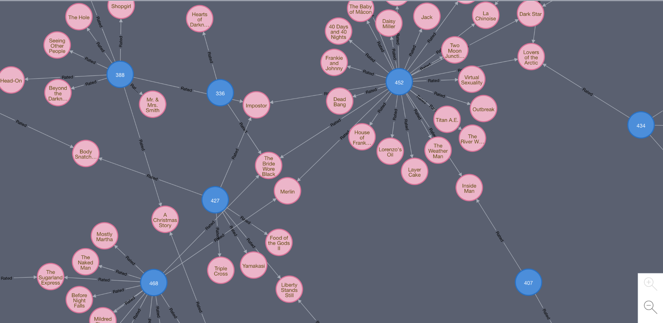

1. Query to get most similar users

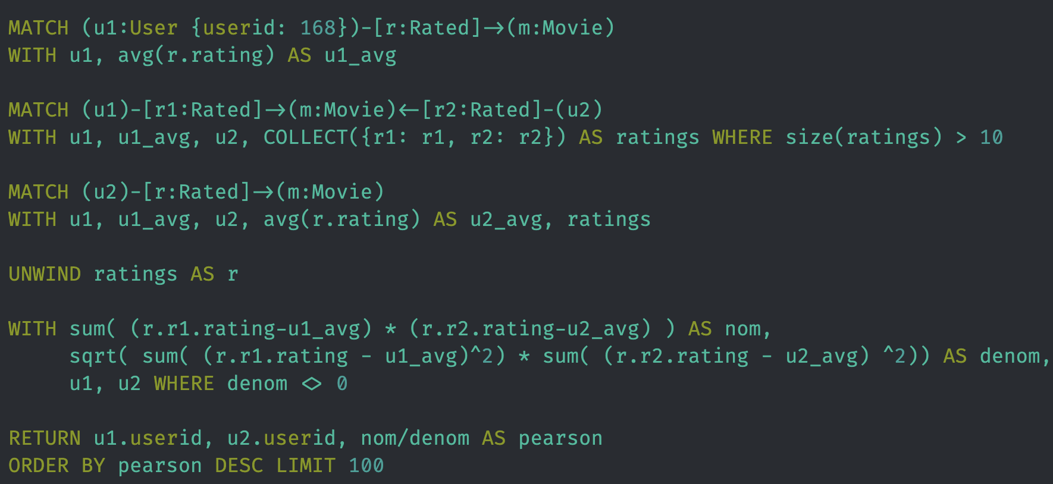

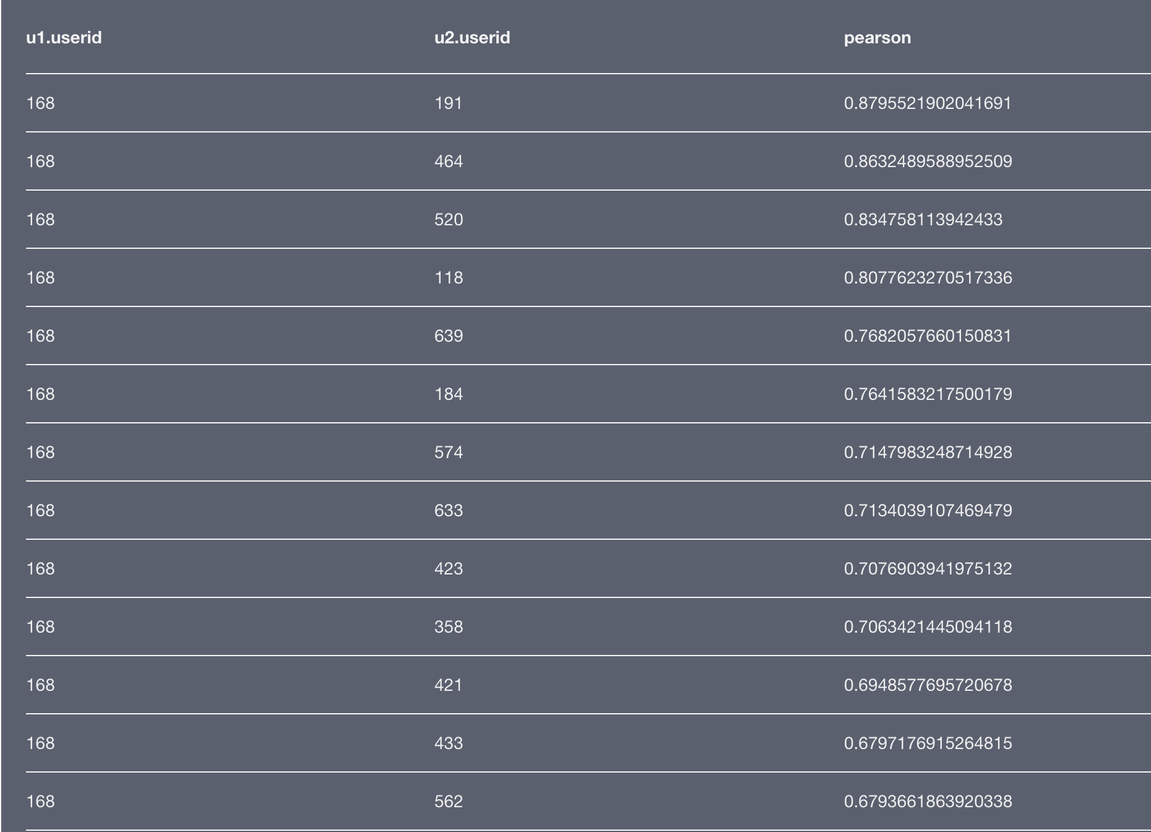

1. Query to get movie recommendations and scores

